**EXPERIMENT 11**

**Change the Hardware compatibility of a VM (Either by cloning/creating a new one) that is already created and configured.**

Step 1: Create a new virtual Machine

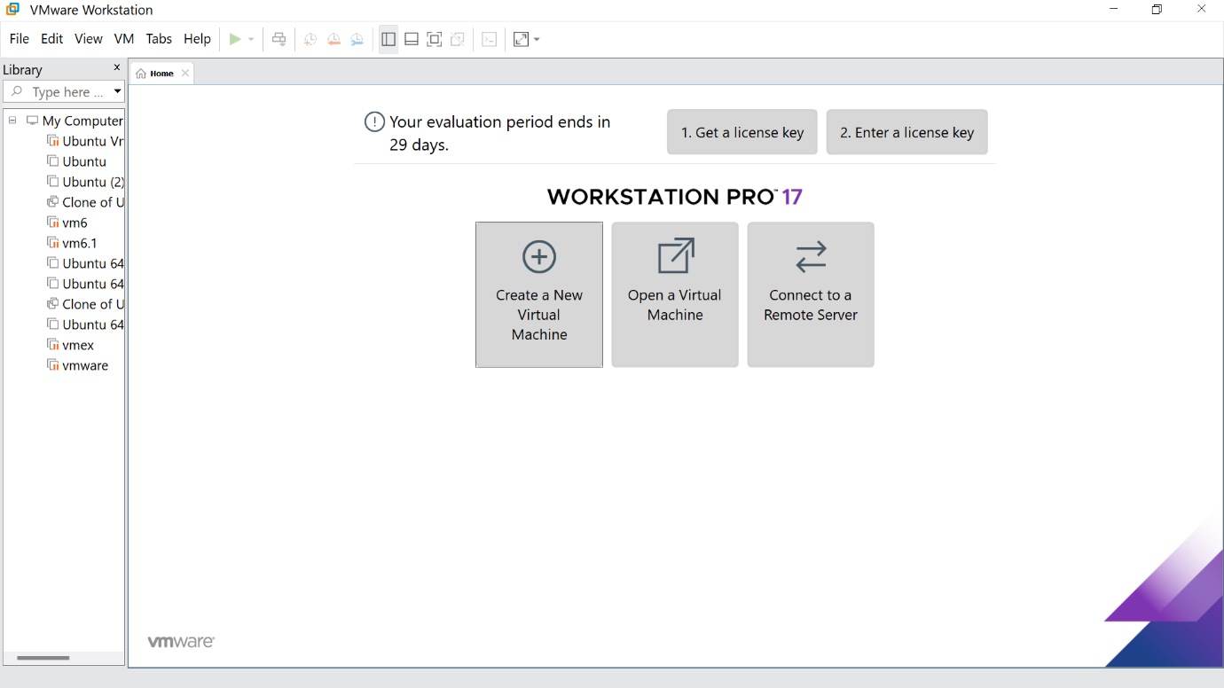

Step 2: Click the Typical option and click Next

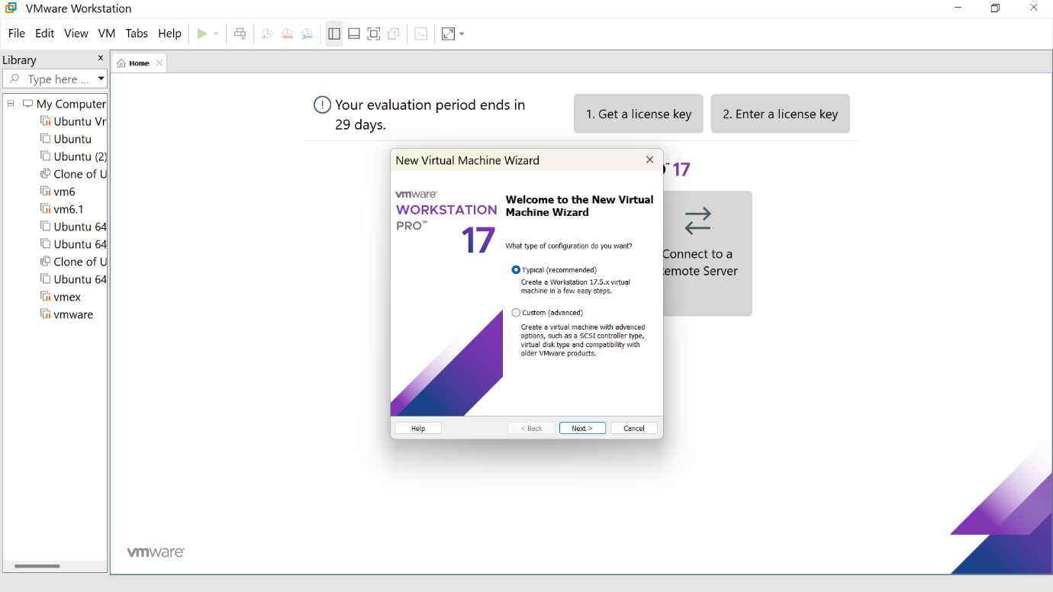

Step 3:Click the install option and proceed to the next step

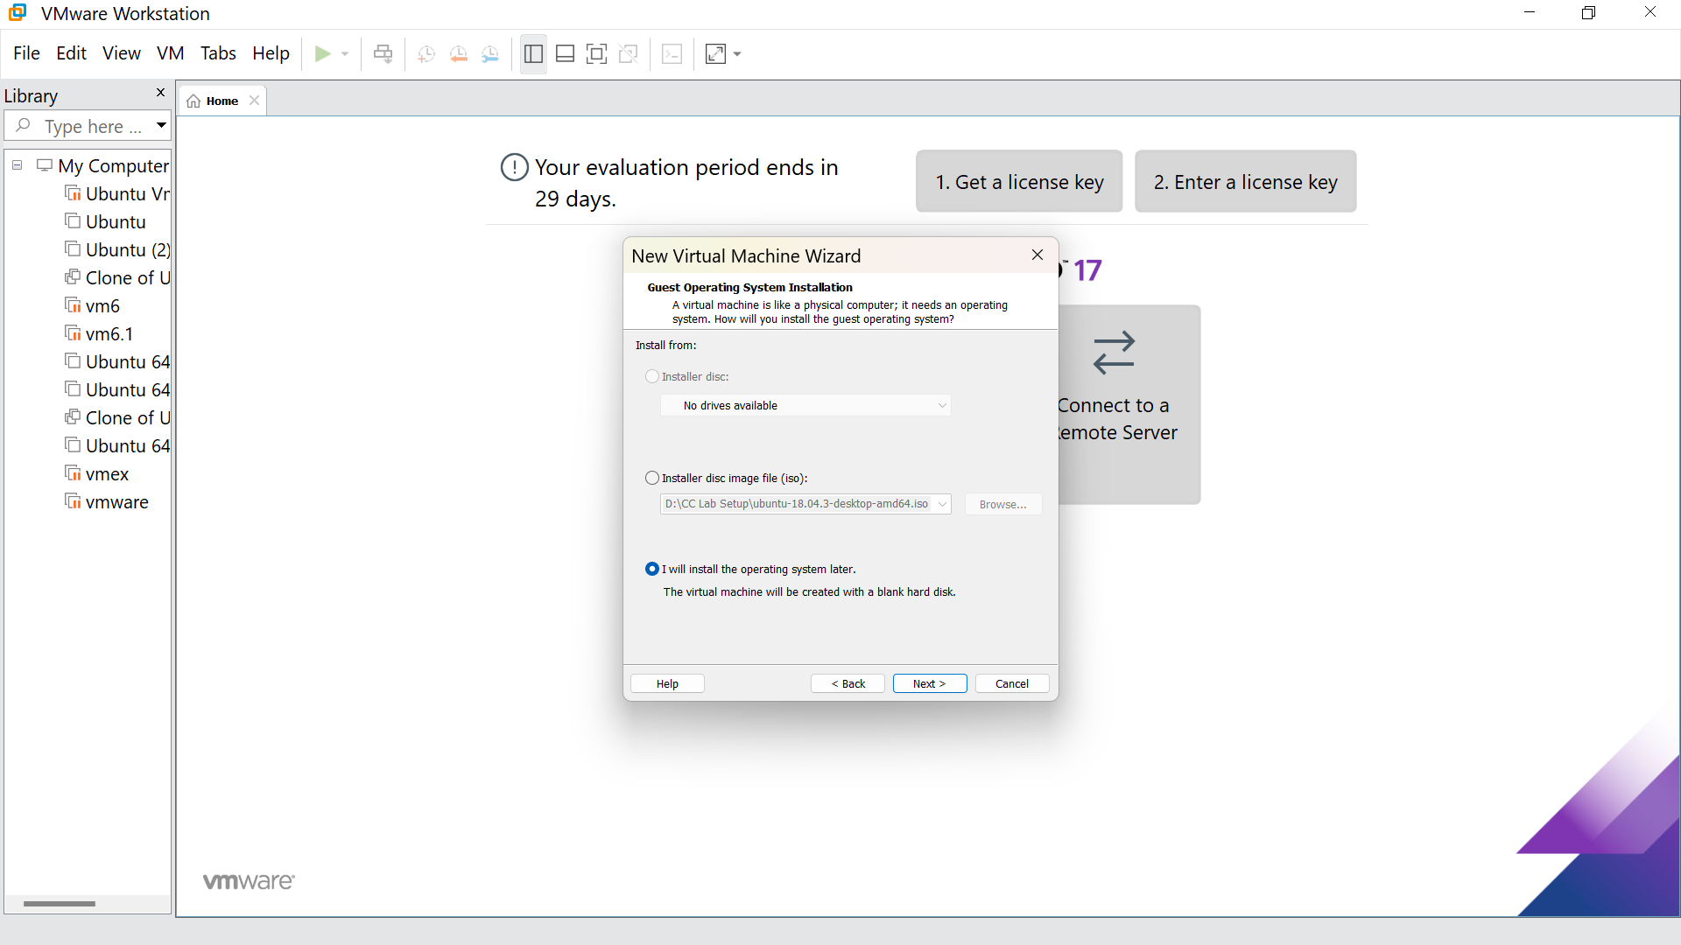

Step 4: Select Linux option and click Next

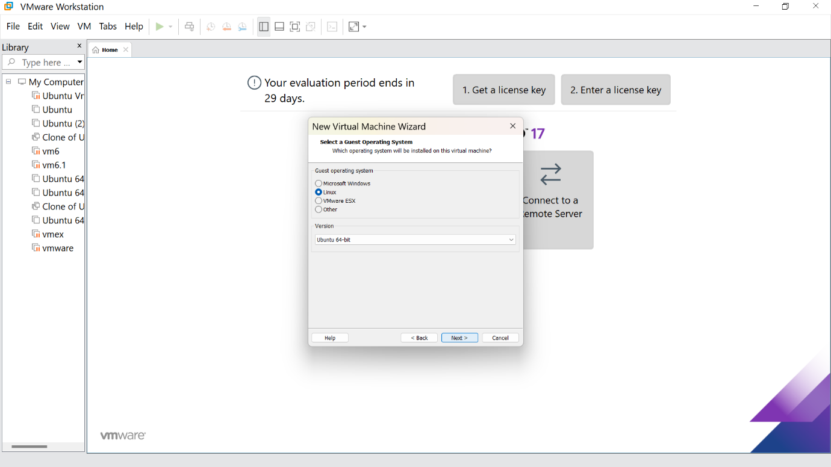

Step 5: Give the name for the virtual machine(optional) and click next

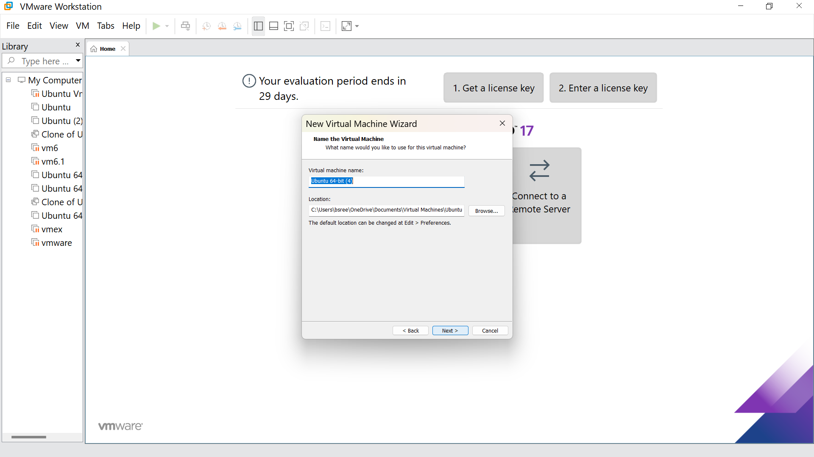

Step 6: Select the option to store the disk in single file and click next

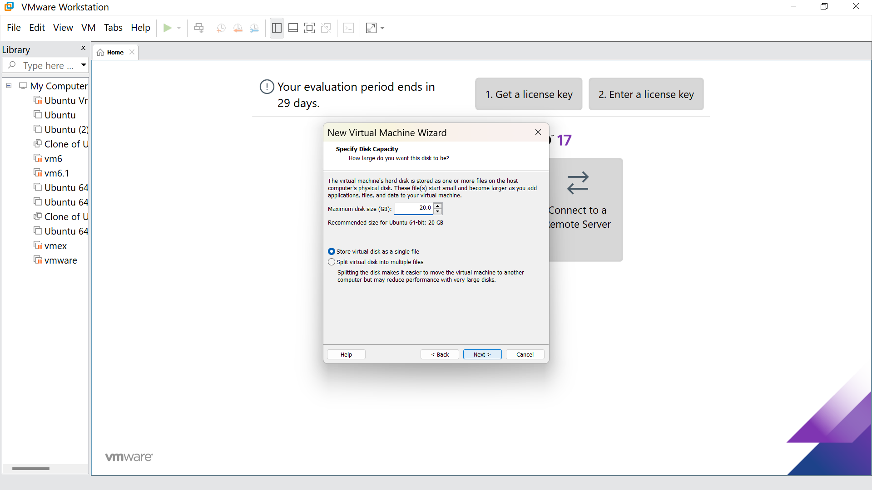

Step7:Our new VM is ready, click Finish

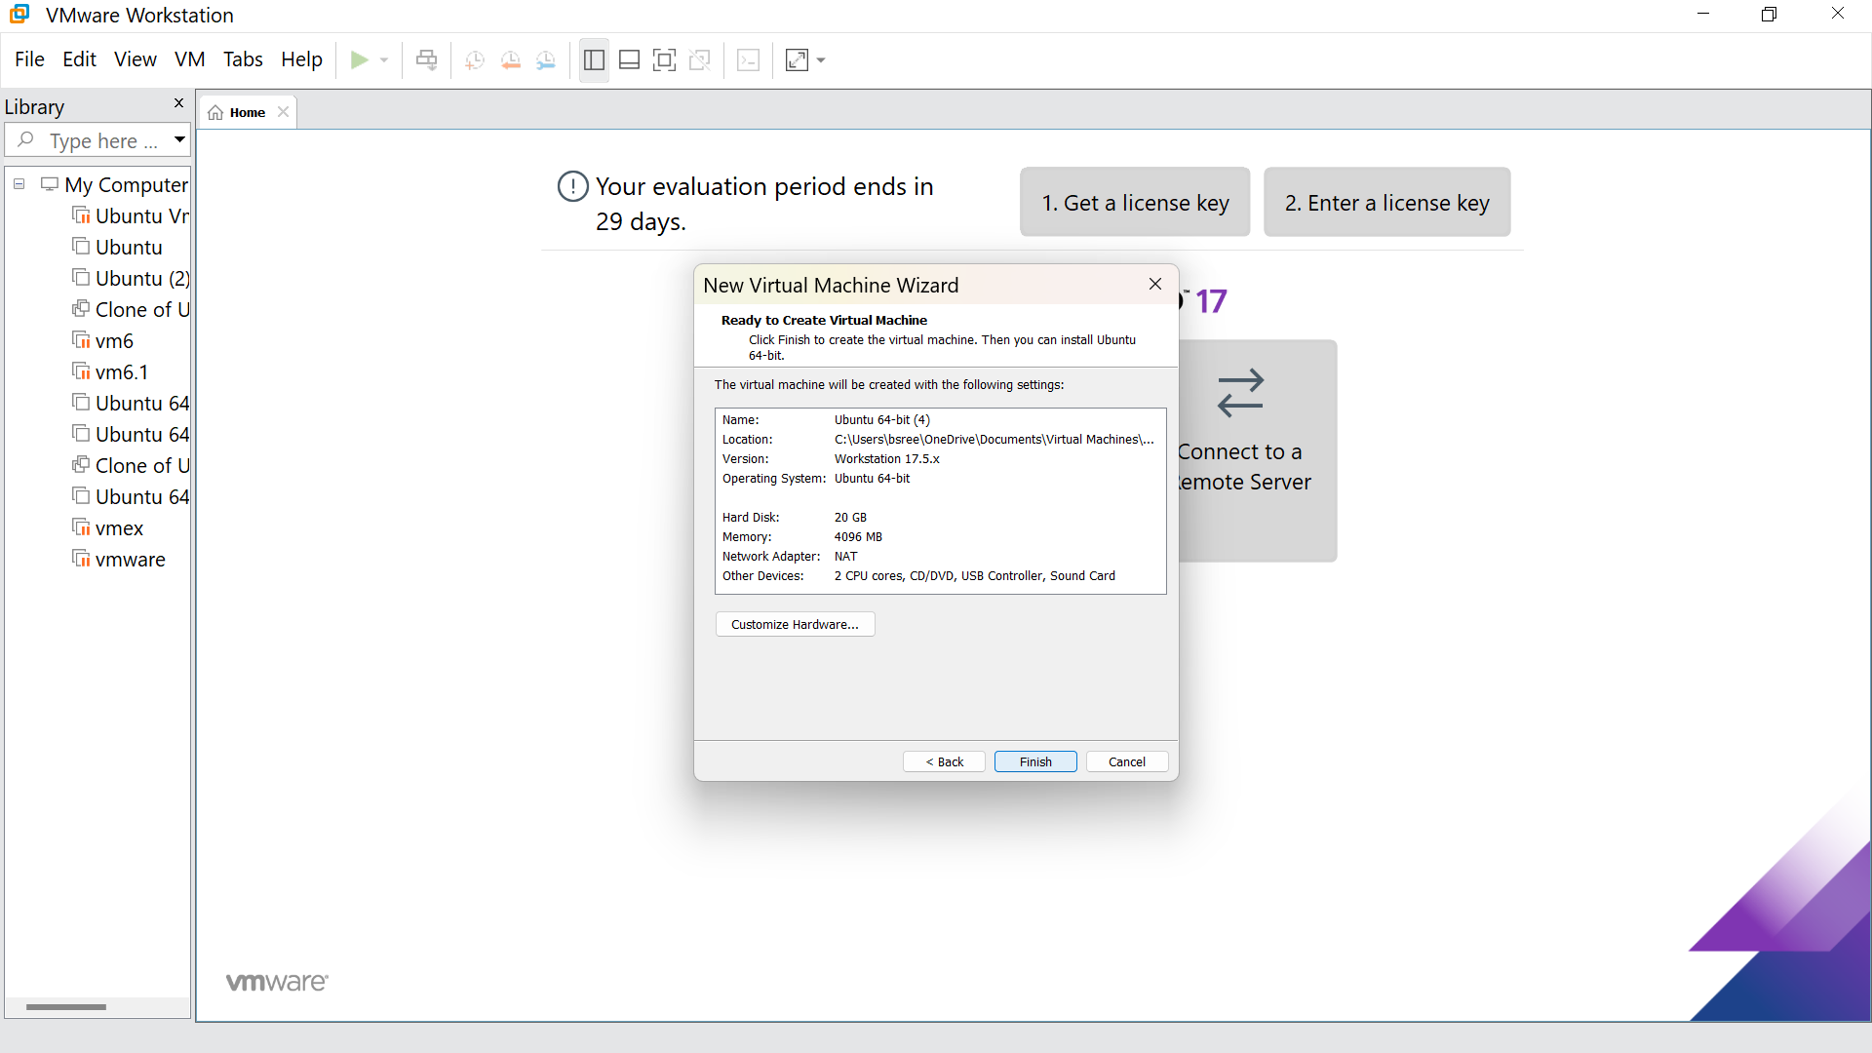

Step 8: This is the creation of VM

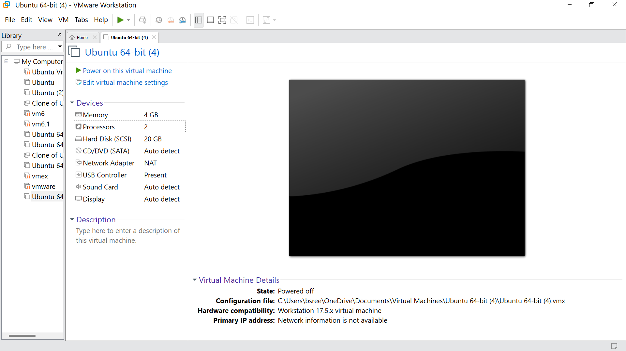

Step 9: Go to the processors and give the number of processors as per your requirement, click ok

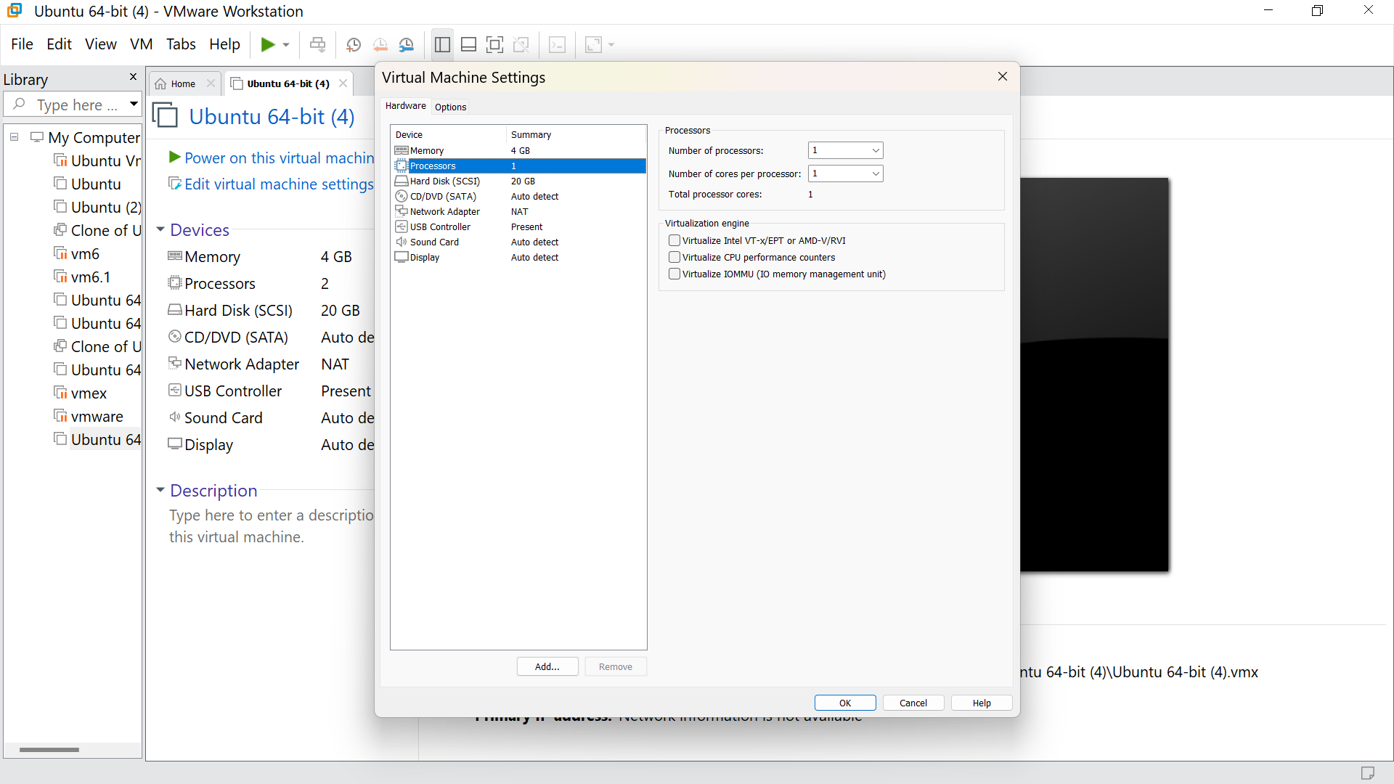

Step 10: Hence we got the output

